**CS223 Preliminary Report**

In total, 4 ICs are used including:

1. One 74LS04 HEX Inverting Gate (04’),
2. One 74LS08 Quad2-Input AND Gate (08’),
3. One 74LS32 Quad2-Input OR Gate (32’),
4. One 74LS86 Quad2-Input XOR Gate (86’).

For all IC’s used in this schematics, pin 7 is for GND and pin 14 is for Vcc (+5V).

Circuit Schematics for the circuits in figure 2 (Half adder at left, half substractor at right).

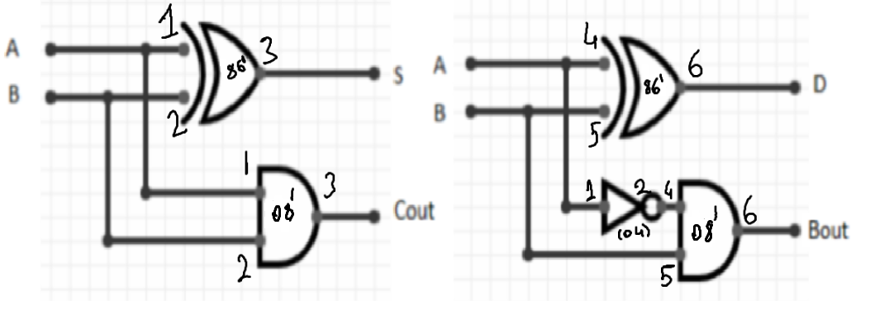

Circuit Schematics for the Full Adder in the figure 3.

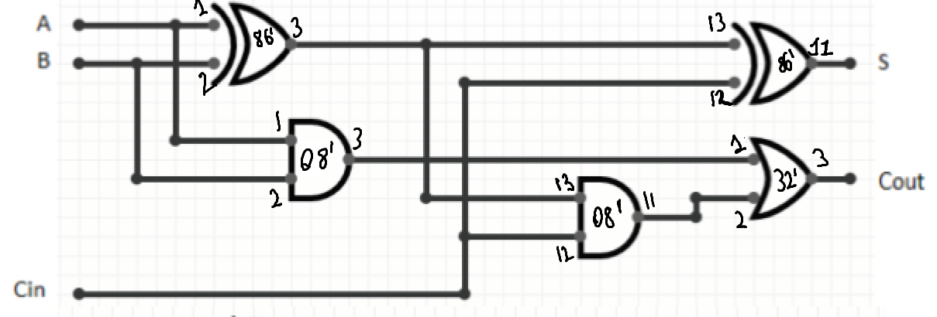

Circuit Schematics for the Substractor in the figure 3.

